# 

# Tips for Error-Free FPDS Reporting – PSC

# Product Service Code (PSC)

Congress and other government agencies use the Federal Procurement Data System (FPDS) data to monitor NIH contracting spending/achievements throughout the year.

FAR 4.604(b)(1) states that the responsibility for completion and the accuracy of the individual contract action report resides with the contracting officer who awarded the contract actions.

# FPDS Data Dictionary Definition - Products/Service Code

The code that best identifies the product or service procured. Codes are defined in the Product and Service Codes Manual.

* **Product and Service Code Manual** - PSC <https://www.acquisition.gov/psc-manual>.

Pick the code that best identifies the product or service procured. If more than one (1) code applies, then report the code that represents most of the ultimate contract value.

An incorrect entry will trigger FedDataCheck (FDC) #19, #64, or #154.

In addition, the following FDC Alerts (#60, #96, #97, #98, #123, and #141) are triggered for other FPDS field values if the **PSC** is **exempt** or **does not apply**.

Decision Making Time! PRISM In-Progress – Acquisition tab - 8A – Primary Product/Service Code. If the preponderance of the buy is for Goods or Supplies, the appropriate Product/Service code will begin with a number. If the preponderance of the buy is for Services, the appropriate Product/Service code will begin with a letter.


All contract awards must include an entry for the **Product/Service Code –** FDC #19.

PRISM In-Progress to FPDS – Draft - 
Populated FPDS field values must be corrected in PRISM before routing the document for approval. FPDS is a web-based application. Save Draft – After Editing, Validating, and before Exiting the FPDS record.


To improve data in **FPDS** and **eliminate** the **FDC** Alert, follow the tips below **before** routing the document for approval.

If the preponderance of the buy is for **Products**, then…

* **PRISM In-Progress – PSC (Products)**
  + **8A Primary/Product Service Code** must reflect a code that begins with a **number** and **not** a letter – FDC #64.
  + **6T-Inherently Governmental Functions** must be blank. FPDS – Select One equate to a blank value – FDC #141.
  + **6F-Performance Based Service Acq**, select Not applicable – FDC #60.
* **FPDS Draft – PSC (Products)**
  + Enter the Vendor’s Zip Code or Postal Code, whichever applicable in the **Place of Performance Zip Code (+4)** field – FDC #123.
    - **Place of Manufacture** field must display a response appropriate for **products**, for example, Mfg. in the U.S.
* **Products** are **exempt** from **Labor Standards**, **Materials, Supplies, Articles, Equipment**, and **Construction Wage Rate Requirements –** FDC #96, #97, #98.

If the preponderance of the buy is for **Services**, then…

* **PRISM In-Progress – PSC (Services)**
  + **6T-Inherently Governmental Functions** select the appropriate response, the field **cannot** be blank.
  + **6F-Performance Based Service Acq**, select the appropriate response, the field **cannot** be Not applicable.
  + **Do Not Select PSC R497 - SUPPORT- PROFESSIONAL: PERSONAL SERVICES CONTRACTS –** FDC #154.
* **FPDS Draft – PSC (Services)**
  + Enter the Zip Code or Postal Code, whichever applicable in the **Place of Performance Zip Code (+4)** field where the **Services** are being performed – FDC #151.
    - **Place of Manufacture** field must display a response appropriate for **services.**
  + Select the appropriate response for **- Labor Standards**, **Materials, Supplies, Articles, Equipment**, and **Construction Wage Rate Requirements**.

# Contractor Responsibility Assessment (CRA)

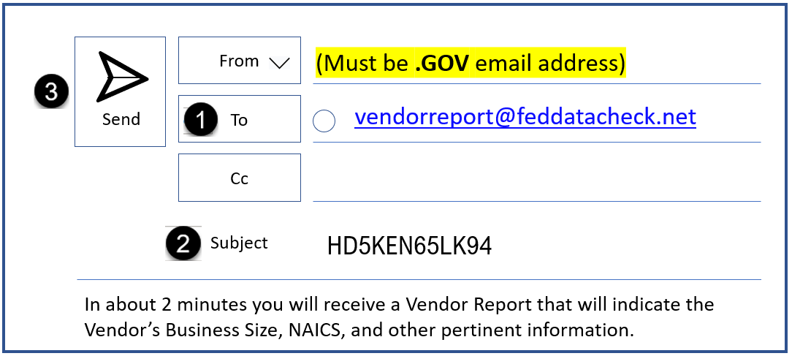

Although the **System for Award Management (SAM)** is the official source for vendor information. Use the **CRA** to help you find the Vendor’s **PSC**.

Open **Outlook**, address an email to [vendorreport@feddatacheck.net](mailto:vendorreport@feddatacheck.net), in the subject line enter the Vendor’s **Unique Entity ID**, click **Send**.

## **Additional Resources:**

**FPDS Data Dictionary** - <https://www.fpds.gov/downloads/Version_1.5_specs/FPDS_DataDictionary_V1.5.pdf>

**Tips for Error-Free FPDS Reporting** – <https://oalmsps.od.nih.gov/DDO/CDMP/FDCResolutions/SitePages/Home.aspx>

CDMP SharePoint Site. VPN required. At sign-in select Windows Authentication.

The FedDataCheck (FDC) Tool is a product of Potomac Wave Consulting. The tool automatically scans FPDS for data inconsistencies such as FAR violations, Statutory/Legislative violations, and other data inconsistencies. Contracting Officials are alerted via email when a violation or data inconsistency occurs.

# New Training Available – Buy American Non-Availability Waivers

On January 25, 2021, the President signed [Executive Order 14005](https://www.federalregister.gov/documents/2021/01/28/2021-02038/ensuring-the-future-is-made-in-all-of-america-by-all-of-americas-workers), “Ensuring the Future is Made in All of America by All of America’s Workers.” This EO was the catalyst to create a series of actions to enable Federal Agencies to maximize the use of good, products, and material produced in the U.S. On March 7, 2022, the FAR council published [FAR Rule 2021-008](https://www.federalregister.gov/documents/2022/03/07/2022-04173/federal-acquisition-regulation-amendments-to-the-far-buy-american-act-requirements), which included changes to the requirements of the Buy American statute. In response to these complex changes, FAI released a training video, [Amendments to the FAR Buy American Requirements](https://www.youtube.com/watch?v=Fmp0jexRTRY) and FAC 097: Navigating Buy American and Trade Agreements.

# Accessibility Features that Benefit Everyone

There are a many accessibility features in Microsoft Office programs that benefit everyone, for example…

|  |  |
| --- | --- |
| Read AloudRead Aloud (Speech) | Review > Read Aloud (ALT +CTRL + Space) – Microsoft Word  Message > Read Aloud – Microsoft Outlook  There are many reasons to listen to a document, such as proofreading, multitasking, or increased comprehension and learning. Listen to email messages or Word documents. |

|  |  |
| --- | --- |
| Home > Dictate (ALT +`) – Microsoft Word / Outlook / PowerPoint  Use Dictate to record speech to written word. For example, “*I created this sentence using Dictate*.”  Dictate email messages, PowerPoint slides, and Word documents. | Dictate Dictate (Voice) |

|  |  |
| --- | --- |
| Styles / Navigation Pane Navigation Pane | Home > Styles, View > *check* Navigation  Once you create document headers (*headings*) using the [Styles](https://support.microsoft.com/en-us/office/customize-or-create-new-styles-d38d6e47-f6fc-48eb-a607-1eb120dec563#:~:text=Right%2Dclick%20the%20text%20on,appear%20in%20the%20Styles%20gallery.) menu option in Word or Outlook -  Headings appear in the [Navigation Pane](https://support.microsoft.com/en-us/office/use-the-navigation-pane-in-word-394787be-bca7-459b-894e-3f8511515e55), allowing users to quickly find, re-arrange, or remove document sections (MS Word). |

|  |  |
| --- | --- |
| View > Zoom – Microsoft Office 365  Use Zoom to increase or decrease the size of the information presented on the screen.  Tip! *Use when presenting during a Virtual Meeting to help viewers see the information presented.* | Zoom Zoom 100% |

# Shopping with the NIH Supply Center Just Got Faster

The Supply Management Branch within the Division of Logistics Services is excited to announce our newest modernization: express checkout at the Self-Service Store! Our new express checkout will allow customers who are purchasing five items or less to check out in a separate aisle, reducing wait times and increasing productivity in supporting the NIH Mission.

When you walk into the Self-Service Store to secure your items, our team will be ready to support you when it is particularly busy. A team member will open a new lane for customers who have five items or less and will do the checkout on our new tablet system. This will reduce the time spent in line for all customers and offer the same exemplary service you are used to.

This is just one of the many modernizations we are working on to improve your shopping experience. We cannot wait to share the exciting initiatives in store for FY23 and thank you for your continuous support!

If you would like to receive more information or have any questions, contact our Customer Service Team at [NIHSC-CustomerService@od.nih.gov](mailto:NIHSC-CustomerService@od.nih.gov). Thank you and remember- we are ONE NIH!

# Upcoming Course – Accessible Electronic Documentation

**You must register through the Learning Management System (LMS)**

[https://lms.learning.hhs.gov](https://gcc02.safelinks.protection.outlook.com/?url=https%3A%2F%2Flms.learning.hhs.gov%2F&data=05%7C01%7Cdee.dansby%40nih.gov%7Cad19f0f03b1a421099e808da95b43297%7C14b77578977342d58507251ca2dc2b06%7C0%7C0%7C637986898439149364%7CUnknown%7CTWFpbGZsb3d8eyJWIjoiMC4wLjAwMDAiLCJQIjoiV2luMzIiLCJBTiI6Ik1haWwiLCJXVCI6Mn0%3D%7C3000%7C%7C%7C&sdata=IwQDobkZ91diiBM5IRS2JJaVrH%2BUt%2BzRMIiG9yKibzY%3D&reserved=0)

Microsoft Office 365 Accessibility – Word, Outlook, Excel, and PowerPoint

(00243513, Version: FY23)

Date: **Thursday, December 15, 2022** – Time: 10:00 AM to 11:30 AM

Microsoft Office 365 Accessibility – Word, Outlook, Excel, and PowerPoint

(00243514, Version: FY23)

Date: **Thursday, January 19, 2023** – Time: 10:00 AM to 11:30 AM

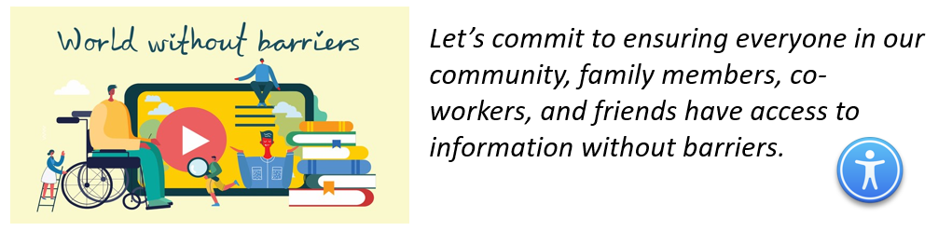

**Acquisition Policy Zone**

Additional OALM communications can be found on the [CDMP SharePoint site](https://oalmsps.od.nih.gov/DDO/CDMP/SitePages/OALM%20Communications.aspx).

HHS Policy Flashes can be found on the [HHS Office of Acquisition Policy Max.gov site](https://gcc02.safelinks.protection.outlook.com/?url=https%3A%2F%2Fcommunity.max.gov%2Fdisplay%2FHHS%2FHHS%2BOAP%2BPolicy%2BFlashes&data=05%7C01%7Cambrosea%40od.nih.gov%7C096a65e849a443a601b908da7fb93357%7C14b77578977342d58507251ca2dc2b06%7C0%7C0%7C637962730643192304%7CUnknown%7CTWFpbGZsb3d8eyJWIjoiMC4wLjAwMDAiLCJQIjoiV2luMzIiLCJBTiI6Ik1haWwiLCJXVCI6Mn0%3D%7C3000%7C%7C%7C&sdata=5q1W%2FZdqmiKyhgDX7AvC5jgRD3WqR8XpjOA7xBSkMks%3D&reserved=0).

|  |  |  |
| --- | --- | --- |
| **Date Issued** | **Policy Communication** | **Description** |
| 7/12/22 | **OALM Communication 22-90**  FY 22 Deadline for Submissions on Buy American Act Waiver for Non-Availability Exception to OALM/MIAO | OALM is requesting the acquisition community submit any remaining Buy American Act non-availability waivers for FY22 awards no later than August 8, 2022 to ensure sufficient time for approval. All waivers must be processed through OALM for HCA approval before final review by the Made in America Office (MIAO). |
| 8/18/22 | **Email from Nancy Norton, Associate Director, OAMP** | The email is to notify all COs and CORs that National Institutes of Health (NIH) Special Notice_2022-05-04 titled NIH Notification to Contractors – COVID 19 Community Level Facility Access Requirements is rescinded.  In accordance with revised CDC Guidelines and NIH safety protocols, **NIH is no longer requiring Contractors to provide daily compliance certification of vaccination or testing for onsite personnel** when the [COVID-19 Community Level](https://www.cdc.gov/coronavirus/2019-ncov/science/community-levels.html) increases from LOW to *MEDIUM or HIGH.* |
| 10/1/22 | **Email from Simplified Acquisition Helpline** | The HHS OIG is conducting pre-audit work to evaluate potential audit objectives related to NIH’s contract closeout process. The OIG is considering audit objectives such as determining whether NIH timely closed out contracts in accordance with the FAR and HHS guidance |
| 10/7/2022  10/12/2022  10/13/2022 | **Email from Simplified Acquisition Helpline** | HHSAR review instructions  HHS is seeking comments on some parts of the HHSAR and they will be sent out to the community in several emails because of file sizes.  Please review the attached files of particular HHSAR sections and provide comment back to us at [simplifiedacquisitionhelp@od.nih.gov](mailto:simplifiedacquisitionhelp@od.nih.gov) before the deadlines established for each group of HHSAR sections |

# Acquisition Training Information

## **Acquisition Training at NIH**

Acquisition training classes that are offered by the NIH Training Center can be accessed at the following link: [Acquisitions Management Courses](https://hr.nih.gov/training-center/course-catalog/acquisitions-management)

## **Federal Acquisition Certification Coursework**

CON courses and other Federal Acquisition Certification required courses can be found at the [NIH Training Center](https://hr.nih.gov/training-center/course-catalog/acquisitions-management), [Federal Acquisition Institute](http://www.fai.gov/), and [Defense Acquisition University](https://www.dau.edu/training).

**Section 508 Accessibility Training**

Section 508 Accessibility Training courses can be accessed at: [CIT Section 508 Accessibility Training Website](http://training.cit.nih.gov/list.aspx?catId=14).

## **Green Purchasing Training**

Green Purchasing Training and other Green Training courses can be found at: [OALM Green Purchasing Website](http://oalm.od.nih.gov/GreenPurchasingForWebsite).

**THANKS!**

We would like to thank all those who contributed to this and future editions of the OALM Newsletter.

The OALM Newsletter will be published four (4) times in calendar year 2022. We encourage staff to submit articles that would be of interest to our readers. We will do our best to include such articles in future editions of the OALM Newsletter.

Please address all correspondence to the editors: Alan Ambrose, [AmbroseA@od.nih.gov](mailto:ambrosea@od.nih.gov), Jesse Lee, [Jesse.Lee2@nih.gov](mailto:Jesse.Lee2@nih.gov), Luke Makenzie, [Luke.Makenzie@nih.gov](mailto:luke.makenzie@nih.gov), or Michele McDermott, [McDermottMl@od.nih.gov](mailto:McDermottMl@od.nih.gov).

If you have any questions or comments regarding the information, policy and/or procedures published in this issue, you may contact Jesse Lee at the e-mail address above. For future issues please contact the Simplified Acquisitions Helpline on 301-496-0400 or via e-mail at [OALMnewsletter@mail.nih.gov](mailto:OALMnewsletter@mail.nih.gov) and you will be referred to the appropriate editor.